# Week 02

* Univariant 🡺 relation of one variable
* Bivariant 🡺 relationship between 2 variants
* Multivariant 🡺 relationship between multiple variables
* Association 🡺 relationship between 2 variants 🡪 scatter diagrams & covariance
* Correlation 🡺 strength of the relationship
* Causation 🡺 when one variable is changed, what happens to the other variable

## Measures of variability

|  |  |
| --- | --- |
| **Range**:  Q1 = [(n+1)/4]th item  Q2 = [(n+1)/2]th item IQR = Q3 -Q1  Q3 = [3(n+1)/4]th item  **Variance**: *VAR.S(data cell range) $S^{2}= \sum{\frac{{\left(X_{i}- \overline{X}\right)}^{2}}{n-1}}$*  for a sample $σ^{2}= \sum{\frac{{\left(X_{i}- μ\right)}^{2}}{N}}$ for a population  **Standard Deviation:** *STDEV.S(data cell range)*  The positive square root of variance | **Coefficient of variance:**  How large the SD is in relation to the mean $\frac{S}{\overline{X }}*100\%$ for a sample $\frac{σ}{\overline{μ }}*100\%$ for a population |

## Covariance

* Measure of linear association between 2 variables
  + Positive value 🡪 positive relationship
  + Negative value 🡪 negative relationship

|  |  |
| --- | --- |
| For Sample: $$S_{xy}=\frac{\sum{\left(x_{i}-\overline{x}\right)\left(y_{i}-\overline{y}\right)}}{n-1}$$ | For population: $$σ_{xy}=\frac{\sum{\left(x_{i}-σ_{x}\right)\left(y_{i}- μ_{y}\right)}}{N}$$ |

## Correlation Coefficient

* Measure linear association and not necessarily causation.
  + Values near (-1) 🡪 strong negative linear relationship
  + Values near (+1) 🡪 strong positive linear relationship
  + Values closer to 0 🡪 weaker relationship

|  |  |
| --- | --- |
| For samples: $$r_{xy}=\frac{S_{xy}}{S_{x}S_{y}}$$ | For population: $$ρ_{xy}=\frac{σ_{xy}}{σ_{x}σ_{y}}$$ |

# Week 03

## Simple Linear Regression Model

|  |  |
| --- | --- |
| Simple linear regression model: $$y= β_{0}+ β_{1}x+ ε$$ $β_{0} \& β_{1}$ are parameters  Ε is the error term | Simple linear regression equation:  🡺 *y=mx+c $β_{0}$*  is the y-intercept of the regression line $β_{1}$ is the slope of the regression line |
| Estimated Simple linear regression eqn: | |

## Least Squares Method

|  |  |
| --- | --- |
| Least Squares Criterion:  🡪 observed value for the *i*th observation  🡪 estimated value for the ith observation | Slope for the Estimated Regression: $$b1= \frac{\sum{\left(x_{i}- \overline{x}\right)\left(y_{i}- \overline{y}\right)}}{\sum{{\left(x_{i}- \overline{x}\right)}^{2}}}$$ Excel function: =SLOPE (y, x) |
| y-intercept for the Estimated regression eqn:  Excel function: =INTERCEPT (y, x) | |

## Coefficient of Determination

|  |  |
| --- | --- |
| 🡪 total sum of squares  🡪 sum of squared due to regression  🡪 sum of squared due to error | Coefficient of determination: $$r^{2}=\frac{SSR}{SST}$$ Interpretation of percentage value of $r^{2}$ is the percentage of the total variability of y variable explained by the linear relationship between x value and y value. |
| Correlation coefficient: $$r_{xy}=\left(sign of b_{1}\right)\sqrt{r^{2}}$$ $b_{1}$ = slope of the estimated regression eqn. | |

# Week 04

## Multiple Regression

* Regression analysis two or more independent variables (x)

|  |  |
| --- | --- |
| Multiple Regression Model: $$y= β_{0}+ β_{1}x_{1}+β_{2}x_{2}+…+β_{p}x_{p}+ ε$$ $β_{0},β_{1},β_{1},…,β_{p}$ are parameters $ε$ error term | Multipl Regression Eqn:   * no error term because E(y) is the expected value of y/ mean of y |
| Estimated Multiple regression eqn: | |

## Interpreting coefficients

In a Multiple regression analysis:

* + (coefficients of x variables) represent an estimated change in $y$ corresponding to a one unit change in $x_{1}$, when all other variables are held constant.
  + 🡺 when x variable is increased by1 unit the y variable will be increased/(decreased) by $b1$ units.

## Testing for Significance

* F test 🡪 overall significance
* ‘t’ test 🡪 test if individual independent variable is significant
* Significance F 🡪 p-value used to test overall significance
* In order to compare the total model significance, we need to compare the P value and α value
* If p value < α, the null hypothesis ( $H_{0})$ will be rejected.

|  |  |
| --- | --- |
| **Testing For Significance** | |
| F test: **Hypothesis: $H_{0}: β_{1}= β_{2}=…= β_{p}=0$ $H_{α}: β_{2}≠ 0$**    one or more of the parameters is not equal to zero  **Test Statistics: $$F=\frac{MRS}{MSE}$$**  **Rejection Rule:**  Reject $H_{0}$ if $p-value≤ α$ or if $F≥ F_{α}$ $$F_{α}=\frac{\left(\frac{SSR}{p}\right)}{(\frac{SSE}{n-p-1})}$$ p🡪 no. of independent variables/predictors  n 🡪 sample size | **t test:**  **Hypothesis: $H_{0}: β_{i}=0$ $H_{α}: β_{i}≠ 0$**      **Test Statistics:**  🡪 coefficient of the predictor  🡪 standard error of predictor  **Rejection Rule:**  Reject $H_{0}$ if $p-value≤ α$ or  if $t≤ {-t}_{\frac{α}{2}}$ or $t≥t_{\frac{α}{2}}$ |

#### Multicollinearity:

* Correlation among predictors.
* Highly correlated 🡺
  + Not possible to determine the separate effect of any predictors on the dependent variable
  + Not a serious issue if the estimated regression is used only for the predictive purposes
* VIF (Variance Inflation Factor)
 $VIF=\frac{1}{1-R^{2}}$

 + If
    - VIF = 1, there is no multi-collinearity
    - VIF > 5, the multi-collinearity exist in-between independent variables.

## Categorical Independent variables

$R^{2}=\frac{SST}{SSR}$ $R_{α}^{2}=1-\left(1- R^{2}\right)\left(\frac{n-1}{n-p-1}\right)$

* If the $R^{2} and R_{α}^{2}$ are close can say that the estimated regression equation does a good job of explaining the c=variability in dependent variable.

## Residual Analysis

* For simple linear regression,

the residual plot against $\hat{y}$ and the residual plot against $x$ provide the same information.

* In multiple regression analysis,

it is preferable to use the residual plot against $\hat{y}$ to determine if the model assumptions are satisfied.

# Week 05

## Linear Programming

* Objective of business decision frequently involve:
  + Maximizing profit
  + Minimizing cost
* Model components
* Objective function 🡪 linear mathematical relationship that describe the objective as the function to be maximized/minimized.
* Constrains 🡪 requirements/restrictions placed on the decision variable relationships.
* Parameters 🡪 numerical coefficients/constants used

# Week 7

## Transportation Problem

Assumptions:

* Each source has a fixed supply of units, where all the supply is distributed among destinations.
* Each destination has a fixed demand for units, where this should be received completely.
* Cost of distribution of units from a source to a destination is directly proportional to the no. of units distributed

Feasible solution property: $\sum_{i=1}^{m}{S_{i}}= \sum_{j=1}^{n}{d_{j}}$

Integer solution property: In cases where $S_{i}$ and $d_{j}$ have integer values, all the basic variables in every basic feasible solution have integer values.

When the total of demand is not the same as of the total of supply a **slack variable (dummy destination)** is used to represent the remaining units.

#### LP formulation:

Minimize: $Z= \sum_{i=1}^{n}{\sum_{j=1}^{m}{c_{ij}x_{ij}}}$ c – cost x - value

Subject to:

$\sum_{i=1}^{m}{x_{ij}}= S_{ij} for i= 1,2,…,n$

$\sum_{i=1}^{n}{x_{ij}}= d_{ij} for j=1,2,…,m$

$$x_{ij}≥0 for all i and j$$

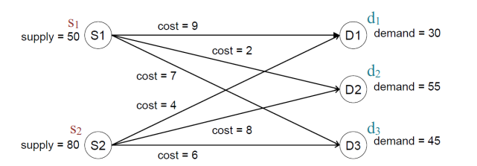

Minimize: $Z=9x_{11}+2x_{12}+7x_{13}+ {4x}_{21}+8x_{22}+6x_{23}$

Constraints:

$x_{11}+ x_{12}+ x_{13}=50 ----(1)$*Minimum transportation cost 530

$$x_{21}+ x_{22}+ x_{23}=80 ----(2)$$

$$x_{11}+ x_{21}=30 ----(3)$$

$x_{12}+ x_{22}=55 ----(4)$

$$x_{13}+ x_{23}=45 ----(5)$$

$$x_{ij}≥0 for all i and j ----(6)$$

## Assignment Problem

Assumptions:

* No. of assignees = no. of tasks
* One assignee 🡪 one task

#### Model Formulation:

Minimize: $Z= \sum_{i=1}^{N}{\sum_{j=1}^{N}{c_{ij}x_{ij}}}$

Subject to:

$\sum_{i=1}^{N}{x_{ij}}= 1 for i= 1,2,…,N$

$\sum_{j=1}^{n}{x_{ij}}= 1 for j=1,2,…,N$

$$x_{ij}=1 if taks i is assigned to worke j, otherwise 0$$

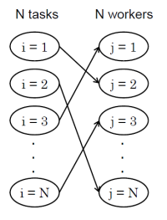

Given N there are:

* N^2 decision variables
* N^2 assignment costs
* N! possible feasible solutions
* 2^(N^2) possible solutions (feasible+ infeasible)

Problem with N = 3:

Minimize: $Z=C_{11}x_{11}+C_{12}x_{12}+C_{13}x_{13}+ C_{21}x_{21}+C_{22}x_{22}+C_{23}x_{23}+ C_{31}x_{31}+C_{32}x_{32}+C_{33}x_{33}$

Constraints:

$x_{11}+ x_{12}+ x_{13}=1 ----(1a)$

$$x_{21}+ x_{22}+ x_{23}=1 ----(1b)$$

$$x_{31}+ x_{32}+ x_{33}=1 ----(1c)$$

$x_{11}+ x_{21}+ x_{31}=1 ----(2a)$

$$x_{12}+ x_{22}+ x_{32}=1 ----\left(2b\right)$$

$$x_{13}+ x_{23}+ x_{33}=1 ----(2c)$$

$$x_{ij}ϵ \left\{1,0\right\} ----(6)$$

## Minimum cost flow problem

$x_{ij}$ = flow though i 🡪 j

Net supply at a node = Flow out – Flow in

$c_{ij}$ = cost per unit flow

$u_{ij}$ = arc capacity

$b_{i}$ = net flow generated at a node *i*

🡪 (supply node)

🡪 (demand node)

🡪 (transhipment node)

#### Model Formulation:

Minimize: $Z= \sum_{i=1}^{n}{\sum_{j=1}^{n}{c_{ij}x_{ij}}}$

Subject to:

$\sum_{j=1}^{n}{x_{ij}}- \sum_{j=1}^{n}{x_{ji}}= b_{i} for i= 1,2,…,n$

$$0≤x_{ij}≤u_{ij} for each i→j$$

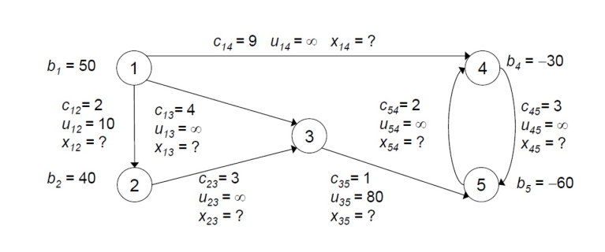

Minimize: $Z=2x_{12 }+4x_{13}+9x_{14}+3x_{23}+x_{35}+3x_{45}+2x_{54}$

Constrains:

$$x_{12 }+x_{13 }+ x_{14 }=50$$

$$x_{23 }-x_{12 }=40$$

$$x_{35 }-x_{13 }- x_{23 }=0$$

$$x_{45 }-x_{14 }- x_{54 }=-30$$

$$x_{54 }-x_{35 }- x_{45 }=-60$$

$$x_{12 }+x_{13 }+ x_{14 }=50$$

$$x_{12 }≤10, x_{35 }≤80, and x_{ij }≥0$$

# Week 08

## Maximum flow problem

* Non-negative maximum flow capacity
* Maximize the total flow from source to sink

#### Model Formulation:

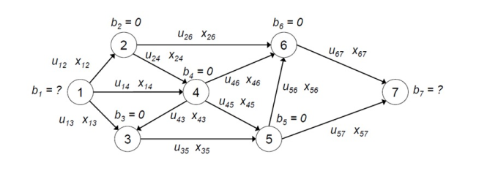

Maximize: $Z=x_{12 }+x_{13}+x_{14}$ (if the flow from the source then the flow is maximized)

Constrains:

$$x_{24 }+x_{26 }- x_{12 }=0 ----(2)$$

$$x_{35 }-x_{13 }- x_{43 }=0 ----(3)$$

$$x_{43 }+x_{45 }+x_{46 }-x_{14 }- x_{24 }=0----(4)$$

$$x_{56 }+x_{57 }-x_{35 }- x_{45 }=0 ----(5)$$

$$x_{67 }-x_{26 }-x_{46 }- x_{56 }=0 ----(6)$$

$$0≤x_{12 }≤u_{ij }, for each i→j$$

## Shortest Path as a flow

* Maximum flow capacity is ∞ for all arcs.
* Flow in each arc in the shortest path 🡪 1, else is 0
* Origin node 🡪
* Destination node 🡪
* Transhipment node 🡪

#### Model Formation:

Minimize: $Z={2x}_{UA }+5x_{UB}+4x_{UC}+{2(x}_{AB }+x_{BA})+7\left(x_{AD}+x_{DA }\right)+\left(x_{BC}+x_{CB}\right)+5\left(x_{BD}+x_{DB}\right)+{3(x}_{BE }+x_{EB})+4\left(x_{CE}+x_{EC}\right)+\left(x_{DE}+x_{ED}\right)+5x_{DV}+7x_{EV}$

Constrains:

$$x_{24 }+x_{26 }- x_{12 }=0 ----(2)$$

$$x_{35 }-x_{13 }- x_{43 }=0 ----(3)$$

$$x_{43 }+x_{45 }+x_{46 }-x_{14 }- x_{24 }=0----(4)$$

$$x_{56 }+x_{57 }-x_{35 }- x_{45 }=0 ----(5)$$

$$x_{67 }-x_{26 }-x_{46 }- x_{56 }=0 ----(6)$$

$$0≤x_{12 }≤u_{ij }, for each i→j$$